Using Softball Hits for Math Fact Fluency:
- Purpose: Derived Facts Strategies for Multiplication and Division
- Purposeful, frequent practice is needed for students to develop the fluency to progress to Phase 3 with all multiplication facts
- The key is to make practice through games as meaningful and strategy focused as possible.
About Games and Math Fact Fluency:
Games are fun. But, more importantly, games are effective ways to support learning. Games provide opportunities for:
- low-stress practice of (1) facts and (2) strategies (both outcomes are critical to math beyond the basic facts!).
- think aloud, an effective learning strategy. Therefore, students should develop the habit of verbalizing their mathematical thinking out loud.
- student listening and learning from peers. Therefore, discussing strategies before and after playing allows students opportunities to learn from each other.
- teachers to formatively assess and plan instruction. Therefore, at times, use an observation tool to record how students are progressing.
Effective math fact fluency games remove time pressure and allow students time to think. That means no time component. Each player has their own cards or dice to roll, so they are not racing each other. Scoring is de-emphasized. Thinking strategies are front and center.
Softball Hits 2 or 3 players
Softball Hits Score Card
Position | My Equation
1
2
3
4
5
6
7
8
9
Materials: three dice, game board with a drawing of a softball field (one per player), score card (one per player
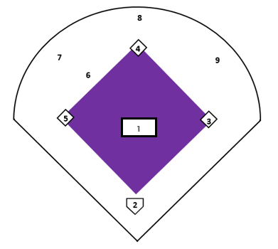

Softball Hits 2 - 3 players
How to Play:
The goal of the game is to “hit” to every position, beginning with pitcher (position 1) and going around the field in order.
- Player 1 take turns rolling three dice.
- Use any two or all three of the numbers and any combinations of operations to create an equation equal to 1.
- If Player 1 can successfully create an equation equal to 1, they can try to use the same numbers to create an equation equal to 2, and so on.
- When Player 1 cannot create an equation for the next desired number, they pass the dice to the next player.
- On the next turn, Player 1 picks up where they left off.
- First player to make equations for 1, 2, 3, 4, 5, 6, 7, 8, and 9 in order wins.

Game in Action: Player rolls 5, 3, and 3. She needs to create an equation equal to the value of 1. She chooses 3 + 3 -5.
I rolled 3, 3, 5 on my dice. I am going to make my equation 3 + 3 = 6. Now, I can subtract 5. 6 – 5 = 1. I get to pitch on the softball field.
Possible Variations:
- Require that all three dice be used.
- Instead of giving a game board to each player, have them collaborate to gets hits to all positions.
- Use a 10-sided dice.
- Allow students to mark off positions in any order.

